Art Nouveau

Art nouveau is an international philosophy and style of art, architecture and applied art—especially the decorative arts—that were most popular during 1890..1905.The name “Art Nouveau” is French for “new art”. It is known also as Jugendstil, German for “youth style”, named for the magazine Jugend, which promoted it, and in Italy, Stile Liberty from the department store in London, Liberty & Co., which popularised the style. A reaction to academic art of the 19th century, it is characterized by organic– especially floral and other plant-inspired– motifs, as well as very stylized, flowing curvilinear forms.Art Nouveau is a philosophy of design according to which artists should work on everything from architecture to furniture, making art part of ordinary life.
The style was influenced strongly by Czech artist Alphonse Mucha, when Mucha produced a lithographed poster, which appeared on 1 January 1895 in the streets of Paris as an advertisement for the play Gismonda by Victorien Sardou, featuring Sarah Bernhardt.It popularized the new artistic style and its creator to the citizens of Paris. Initially named Style Mucha, (Mucha Style), his style soon became known as Art Nouveau.
Art Nouveau was most popular in Europe and the British Islands, but its influence was global. Hence, it is known in various guises with frequent localised tendencies.
In France, Hector Guimard‘s Paris metro entrances were of art nouveau style and Emile Gallé practiced the style in Nancy.
Victor Horta had a decisive effect on architecture in Belgium.
Magazines like Jugend helped publicize the style in Germany, especially as a graphic artform, while the Vienna Secessionists influenced art and architecture throughout Austria-Hungary.
Although Art Nouveau was replaced by 20th-century modernist styles,it is considered now as an important transition between the historicism of Neoclassicism and modernism.Furthermore, Art Nouveau monuments are now recognized by UNESCO with their World Heritage List as significant contributions to cultural heritage. The historic center of Riga, Latvia, with “the finest collection of art nouveau buildings in Europe”, was included on the list during 1997 in part because of the “quality and the quantity of its Art Nouveau/Jugendstil architecture”,and four Brussels town houses by Victor Horta were included during 2000 as “works of human creative genius” that are “outstanding examples of Art Nouveau architecture brilliantly illustrating the transition from the 19th to the 20th century in art, thought, and society”
THE ART NOUVEAU CURVE
a typical art nouveau curve also known as the S-curve or the Whiplash curve
The stylization of the art nouveau designs are distinctly different from the William Morris designs.
The art and design of the art nouveau period is often abstract.
And in both the abstract art and the depictions of flowers, foliage and fauna, the distinctive 'S-curve' is seen.
The art nouveau S-curve is long and elegant - with emphasis on the vertical - it's not a short, fat 'S' - with a fancy flourish on either end.
There is also the 'Whiplash curve' which tilts elegantly in reverse
Art Nouveau Architecture
The Art Nouveau architectural style developed in Europe between 1890 and 1914.
This style grew out of a rebellion against classical ideals in architecture and art.
The major characteristics of Art Nouveau architecture and art were curved forms and ornate embellishments with shapes from nature.
Art Nouveau architects rejected the classical forms of Greek and Roman architecture.
Art Nouveau buildings found their inspiration in the expressive lines and shapes of nature, especially from flowers and other plant life.
Curved lines and arches dominated the exterior of Art Nouveau architecture.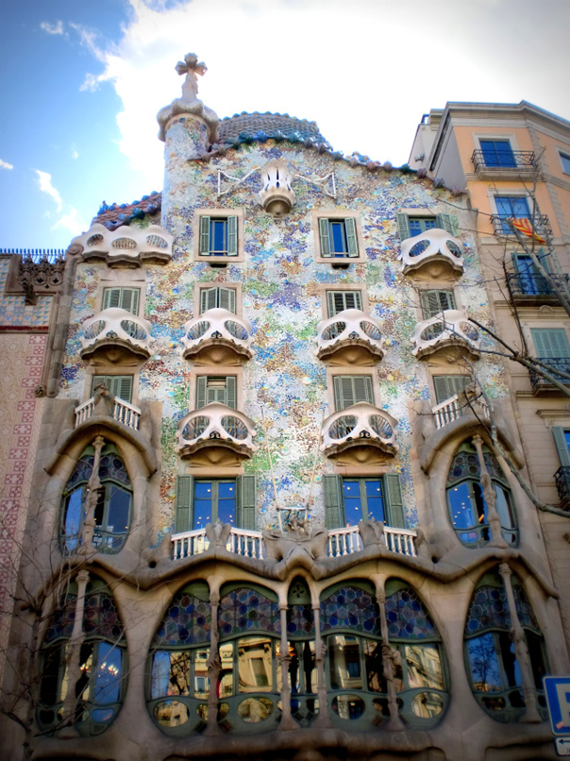
Casa Batllo in Barcelona, Spain
Which has redesigned by Antoni Gaudi between 1905 and 1907 in the Art Nouveau style.
The exterior of Casa Batllo has curved, leaf-like balconies.
The bottom of each balcony has a flower design that can be seen from the street, and the lower floors have undulating arches.
Casa Batllo does not have many straight lines or geometric shapes, as even the corners of the building are curved.
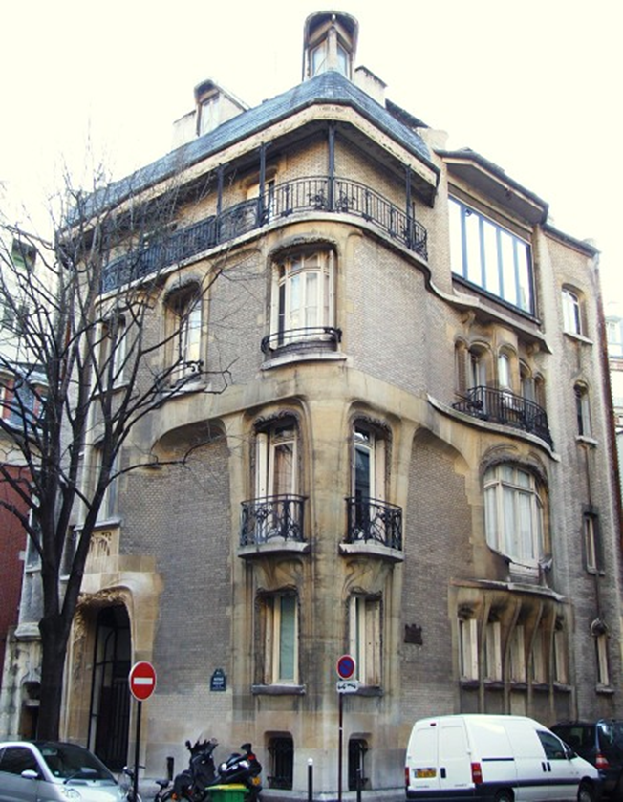
Another example of Art Nouveau architecture is the Hotel Guimard, built by Hector Guimard in 1912 in Paris, France.
The windows of the Hotel Guimard are shielded by arches with root-like designs.
A large balcony at the top of the building has an elaborate wrought iron railing with flowery elements.
The entryway to the house has an arch with asymmetrical, floral designs.
Not only was Art Nouveau evident in external architecture but interior design displayed its standards as well.
Ornate moldings with relief sculptures of plants, flowers and birds were characteristic of building interiors.
Opulent, winding staircases were common as well.
Art Nouveau buildings have many of these features:
• Asymmetrical shapes
• Extensive use of arches and curved forms
• Curved glass
• Curving, plant-like embellishments
• Mosaics
• Stained glass
• Japanese motifs
Examples:
The Wainwright Building
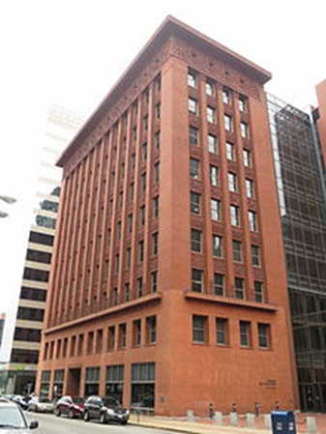
• The first two stories are unornamented brown sandstone with large, deep windows.
• The next seven stories are uninterrupted red brick. Between the piers are horizontal panels decorated with leaf ornamentation.
• The top story is decorated with round windows and terra cotta leaf scroll ornaments inspired by the Notre-Dame de Reims in France.
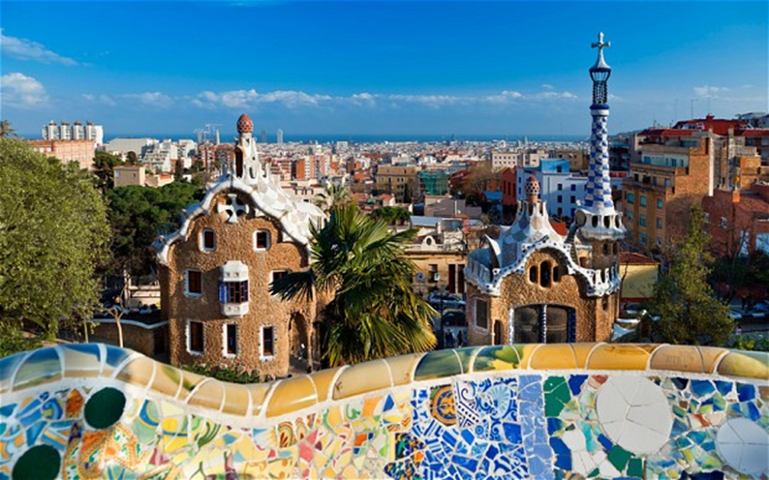
• Parque Güell in Barcelona, Spain by Antoni Gaudí
The entire Guell Park is made of stone, ceramic, and natural elements. For the mosaics, Gaudi used broken ceramic tiles, plates, and cups.
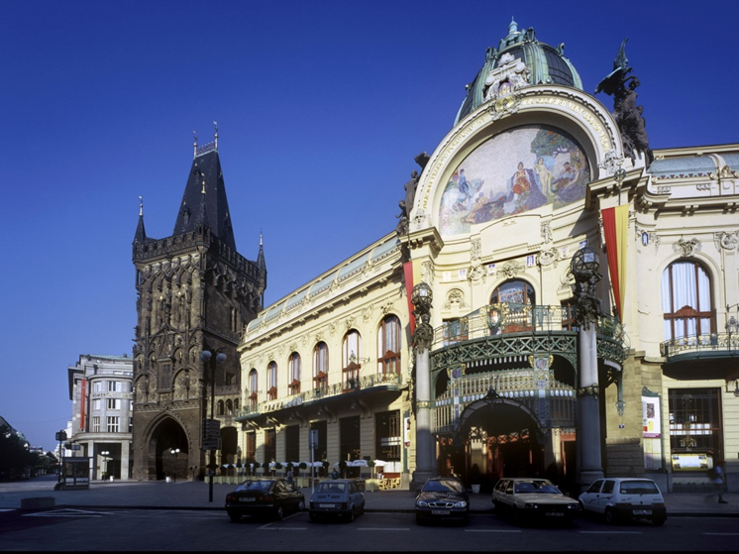
• The Municipal House in Prague, Czech Republic
A tour of the Municipal House is sure to delight. This Art Nouveau beauty is detailed with mosaics, curved glass, sculptures, stained glass, and other artistic touches throughout.
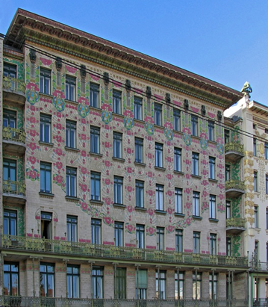
•Majolika Haus in Vienna, Austria by Otto Wagner
Otto Wagner's ornate Majolika Haus (Majolica House) is named after the weather-proof, painted ceramic floral designs on its façade.
Despite its flat,
Rectilinear shape, the building is considered Art Nouveau.
Wagner used new, modern materials and rich color, yet retained the traditional use of ornamentation.
The eponymous majolica, decorative iron balconie
flexible, S-shaped linear embellishment accentuate the building's structure.
Art Nouveau Interior Design
It has been said often that Art Nouveau interior design is in fact the original modern style of the 20th century, as it was the first style to stop looking back in time for inspiration.
Art Nouveau was influenced by ideas of the natural world and what designers experienced around them, borrowing ideas from nature and reflecting them in magnificent fabrics and wall paper.
From 1880 to 1910, art nouveau interior design was the height of originality and design excellence. The concept was first on show in Paris, France and then London, UK. It caused a huge fuss as people instantly loved it or loathed it.
The two distinct looks that were commonly used by nouveau artist are rational, linear lines and curves that take on organic shapes.
The look incorporates stylized flowers, leaves, buds and roots like those shown in the image below. The female form was widely used in the pre-Raphaelite pose with long, flowing hair. Art Deco was also influenced by those elements.
Colors: soft, muted colors were often used so select from a palette assortment of sage and olive green, mustard yellows and brown. Pair those up with beautiful shades of lilac, violet and purple. Peacock blue is stunning against a white backdrop.
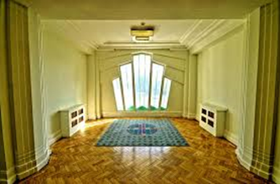
Walls:
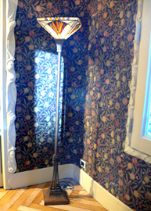

Floors: Polished wooden floorboards are idea to get the art nouveau interior look - a simple rug showing art nouveau designs could be added.Or a plain carpet could be an alternative to the flooring.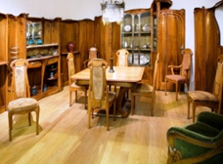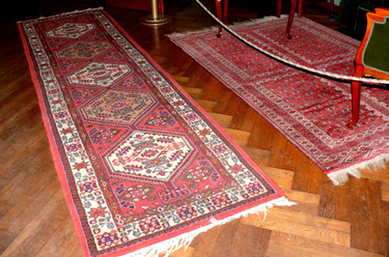
Decor: wasn't always simple, it was however decadent and ornamental. It has simple touches of design and staying true to this period it is warm in color and has a beautiful mix of curvy and straight lines flowing up either side. The organic look of art nouveau interior design always grows from the ground up.
Stained glass panels with curved leading that look like stalks and leaves really help to bring this concept to life. A mix of colorful glass and semi-precious stones can be used to really give a luxurious finish. Stained glass is popular in art nouveau interiors. See it in:
Windows
Door panels
Panels in wardrobes, cupboards and cabinets
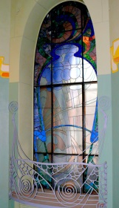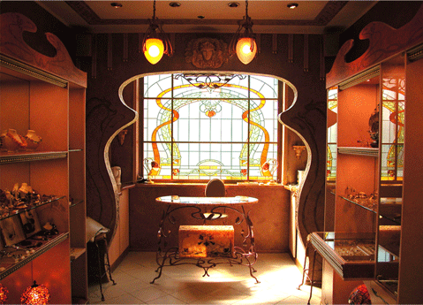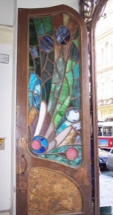
Lighting: no art nouveau interior design would be complete without a Tiffany lamp. Constructed from a bronze base the Tiffany lamps have an umbrella shaped shade, made from spectacularly, interesting stained glass.
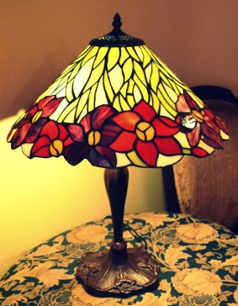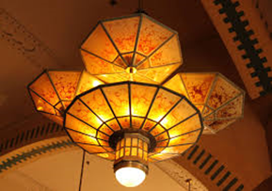
FIREPLACE:
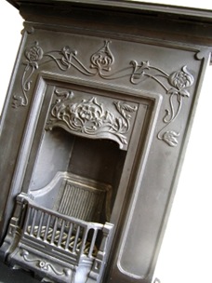
FRAMES AND MIRRORS: Art nouveau frames for artworks and mirrors would have been decorative and well-ornamented
.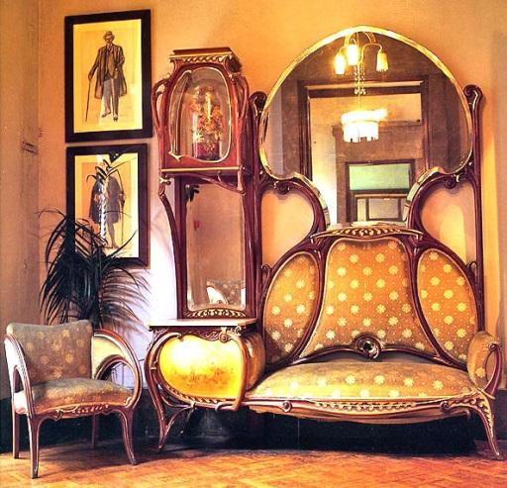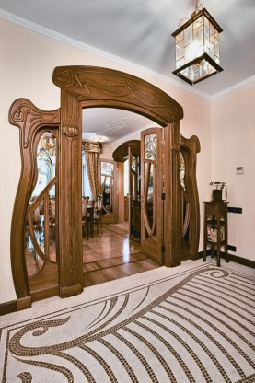
STAIRS: During Art Nouveau period common staircase in dwellings has transformed from dark and dull place to the beautiful and brightly decorated piece of interior decor. Innovation of that period that architects started to put windows on every floor which provided a lot of natural light (before that staircase was in the closed area with no windows). The walls were decorated with bright ornaments and stairs had wrought iron railings:
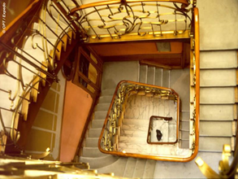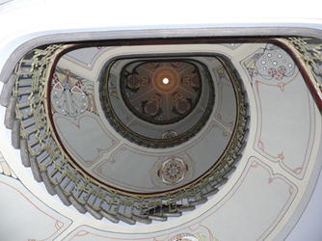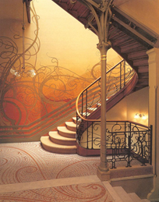
ACCESSORIES: The most popular accessories of Art Nouveau were decorative objects made from stained glass. Among them Tiffany lamps became especially famous.
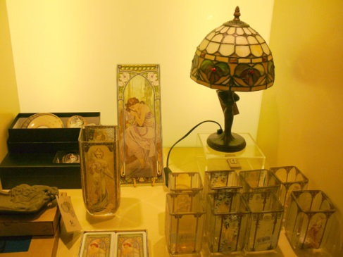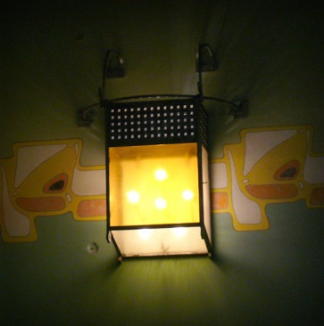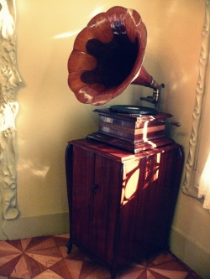
MOTIFS AND THEMES IN ART NOUVEAU INTERIOR DESIGN
Typical motifs seen in these art nouveau designs are:
- Roses (especially Charles Rennie Mackintosh)
- Lilies
- Tulips
- Thistles
- Birds
- Peacocks and peacock feathers
- Butterflies
- Dragonflies
- Moths
Also the beautiful, stylized woman was worshipped in art nouveau designs everywhere - With the 'look' based in the romantic pre-Raphaelite idea of woman, and the typical, sensous S-curves emphasized in her poses.
POPULAR PATTERNS AND ORNAMENTS

- Flowers – were used practically everywhere. The most popular were lily, irises, orchids (it is explained by growing interest in everything exotic in the beginning of XX century) and some local flowers as well (this was connected to the desire of artists to sing the beauty of their homelands)
.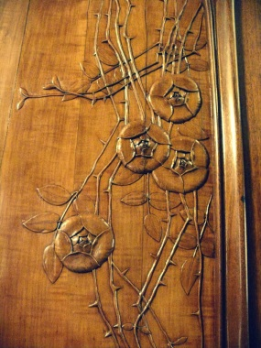
- Beautiful women with long curly hair. I was already talking about growing impact of feminism movement during Art Nouveau period. Women were fighting for their rights, cut their hair, smoked cigarettes, wore trendy hats. This was the time when the world just got over the World War I and many traditional things lost their values. Artists and designers wanted to run from reality into imaginary world with beautiful women with long curly hair, elegant and luxury things, bright, vivid colors. On the other hand, image of “femme fatale” was also very popular and often used
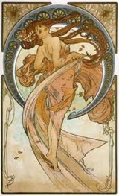
- Insects. Artists were inspired by beauty of nature and used most of its creations as inspiration for their work. Never before insects were so often utilized as decorative motif: grasshoppers, dragonflies, colourful bugs, etc.
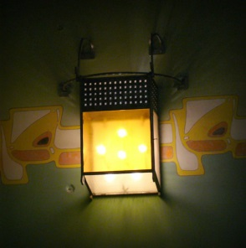
- Birds. Paradise birds, peacocks, parrots – artists were always looking for exotic and colourful creatures
.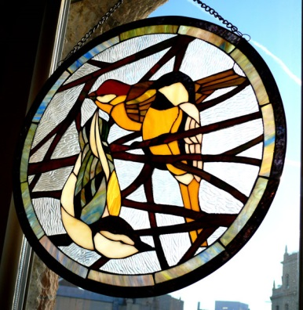
- Whiplash curve - a hallmark of Art Nouveau movement, created by German sculptor Hermann Obrist. It was a part of the artist’s most famous work: wall hanging called “Cyclamen”. Later on it became one of the most popular decorative motifs of Art Nouveau.
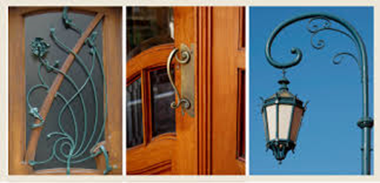
GENERAL CHARACTERISTICS

Flowing lines. This is the hallmark of Art Nouveau. Designers stepped away from strict and boring geometry and got inspired by natural organic forms. Practically every detail of Art Nouveau interior had curved lines: door openings, windows, furniture
: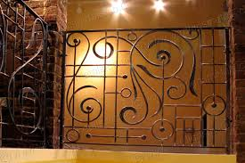

Inspiration from nature. Nature has become the main muse for all artists. Not only they used flora and fauna creations as decorative ornaments but also learned how to extract natural shapes and forms and use them in decorative art
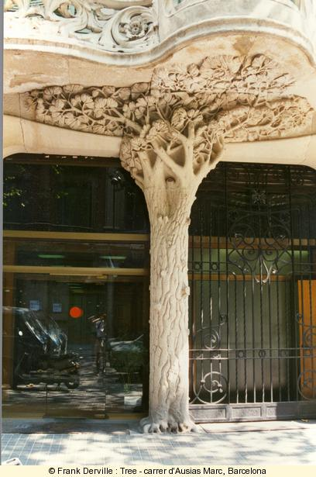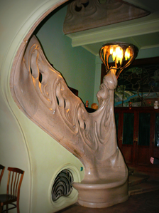

Wrought iron. This material was very popular even before, but in Art Nouveau metal acquired airiness and lightness. The first architect and designer who started to apply it widely was Gaudi - many other artists took inspiration from his works. Wrought iron was a wonderful decoration and designers started to use it in interiors very often: as staircase railings, bars on windows, furniture and decorative objects

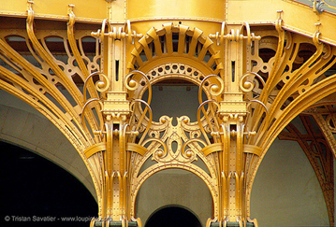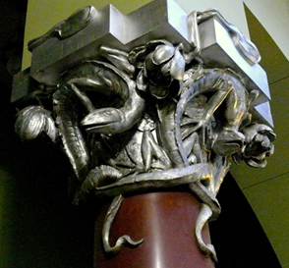
Art nouveau furniture
- Delicately curving lines and floral motifs.
- It has no straight lines at all.
- Chair backs and table legs curve gracefully outward, often intersecting with decorative crosspieces.
- Furniture are usually hard-wearing and sumptuous, ranging from brocades and leather to linen and velvet.
- Artists commonly achieve the intricate carving and graceful curves in art nouveau furniture by using tropical hardwoods.
- Each piece of art nouveau furniture was handmade.
- Though very difficult to carve, hardwoods proved the best materials for making art nouveau furniture.
- Shaping took a very long time, but woods like walnut, oak, and teak hold their shape almost indefinitely once artists twist, carve, and steam them into the proper form.
- Such highly ornamental furniture could not go bare, so artists commonly called on Victorian upholstery techniques to pad the seats of occasional chairs and sofas.
- Heavily embroidered brocade, tapestry fabric, mohair, and leather were among the most expensive, hardest-wearing options.
- Many colors of velvet, linen, and damask fabrics were also available.
- The fabrics could be tufted or smooth, and popular colors ranged from deep jewel tones to soft mauves and creams.
Character of Art Nouveau furniture Art Nouveau furniture has some signature elements which make them unique
- Extreme Curves
- Art Nouveau furniture usually features interesting curves that may contradict how you think furniture should be designed.
• These curves are inspired by nature the bending of the grass in the wind, or the arch of a new plant reaching for the sun
• Some artists referred to the curves in Art Nouveau works as whiplash curves.
• Rhythmic patterns of curvy.
• These curvy lines connect the images in the art and can even be found in beautified plain items, such as dishes, eating utensils, hardware and furniture.

• Organic Inspiration
• An Art Nouveau should immediately make you think of nature.
• Images of Flowers, Plants, Birds or Insects Art Nouveau designers loved to work images of insects, birds, plants and flowers into their furniture.
• These are often carved or inlaid into the furniture as decoration.
- Images of vines that climb the sides of the furniture are also common.
- Art Nouveau is characterized by graceful, sinuous lines.
- The lines are rarely angular.
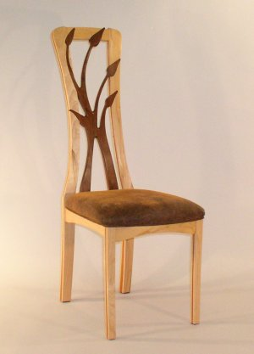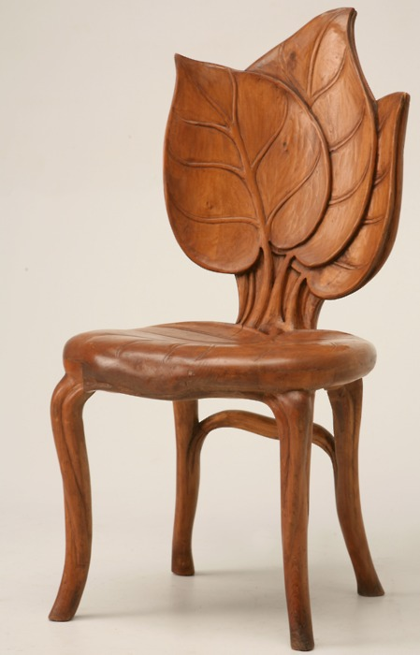

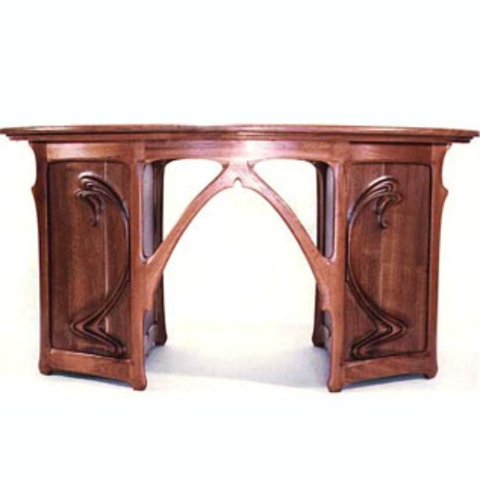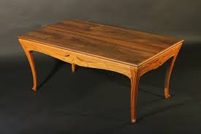

ART NOUVEAU PAINTING
Art Nouveau is considered a "total" art style, embracing architecture, graphic art, interior design, and most of the decrative art including jewellery, furniture, textiles, household silver and other utensils and lighting as well as the fineart.
As an art style, Art Nouveau has affinities with the Pre Raphaelites and the symbolist styles, and artists like Aubrey Beardsley, Alphonse Mucha, Edward Burney Joney could be classed in more than one of these styles. Unlike Symbolist painting, however, Art Nouveau has a distinctive appearance; and, unlike the artisian-oriented Arts and crafts movement, Art Nouveau artists readily used new materials, machined surfaces, and abstraction in the service of pure design.
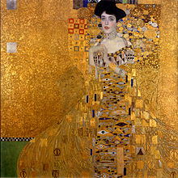

Valentin Serov

The greatest works of Serov's early period were portraits: The Girl with Peaches (1887), and The Girl Covered by the Sun (1888), both in the Tretyakov gallery. In these paintings Serov concentrated on spontaneity of perception of the model and nature. In the development of light and colour, the complex harmony of reflections, the sense of atmospheric saturation, and the fresh picturesque perception of the world, there appeared the features of early Russian impressionism.

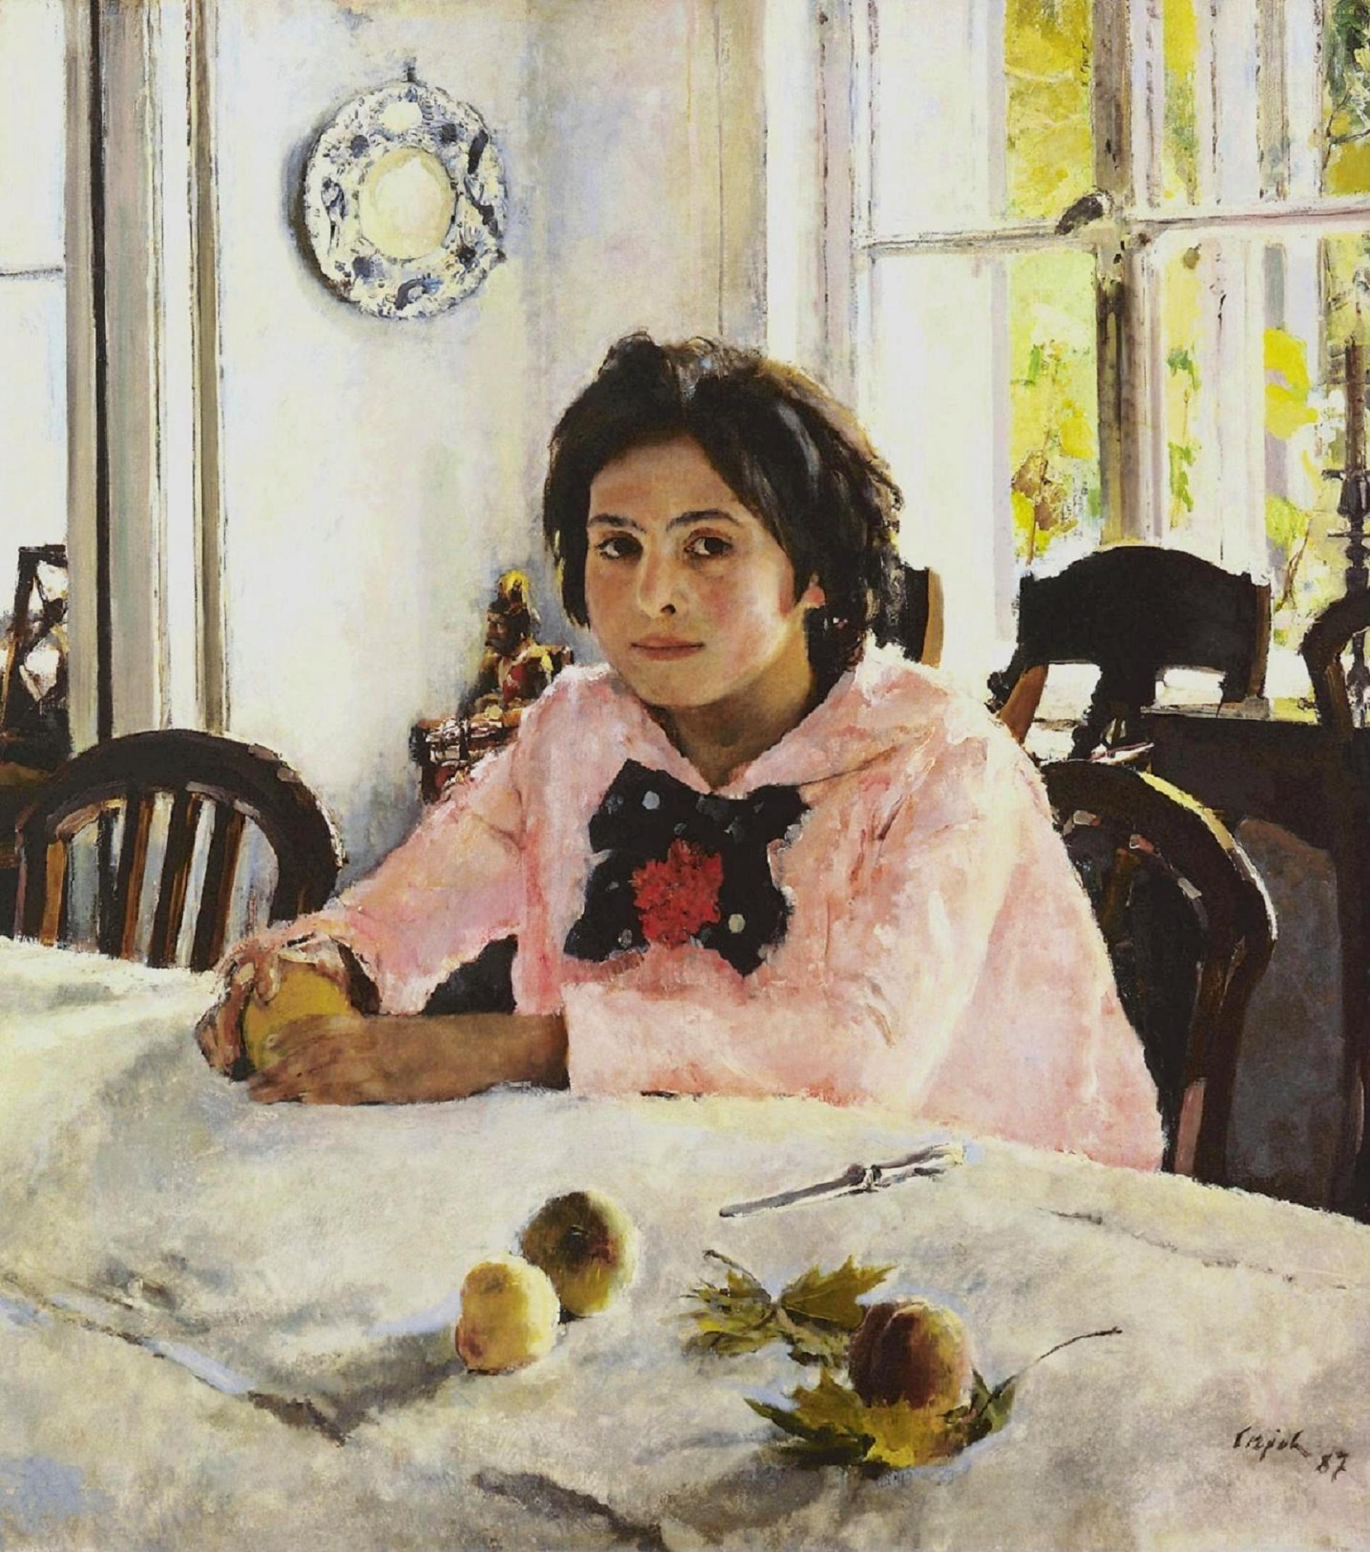 bright and abstract paintings

Ludwik Konarzewski
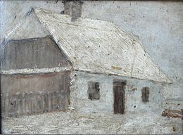The chat near the Cracow, about 1905
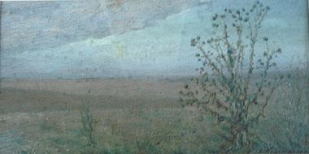The landscape with the teasel, Buzuluk about 1915

He used dull colours and had visible strokes in his paintings.

Gustav Klimt

Gustav Klimt (July 14, 1862 – February 6, 1918) was an Austrian symbolic painter and one of the most prominent members of the Vienna Secession movement. Klimt is noted for his paintings, murals, sketches, and other objects d'art. Klimt's primary subject was the female body, and his works are marked by a frank eroticism.

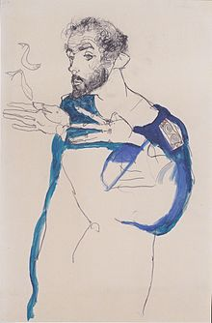 Klimt in a light Blue Smock

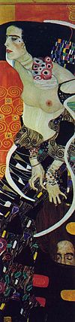
Judith II (1909)
he was a naturalist, symbolist and realist.
Sculptures:
- Signed nude bondage Lazy Bronze sculpture:
Lovers play a wicked sexy game. She tilts her head and her hands are tied up. She happily surrenders to his will. She has a full figure with curvy legs, hips and breast.

- Statue sculpture Panther:
The female lion is quite flexible. Felines are agile and graceful creatures able to jump delicately from high places. This feline perches its hind in the air standing on its back legs.
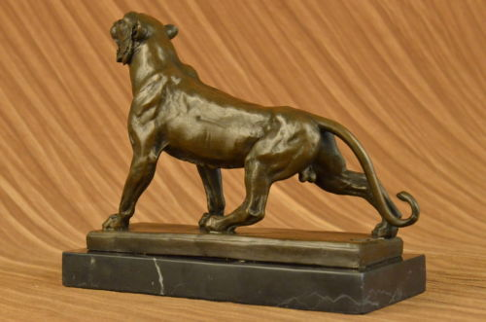

- Bronze sculpture art nouveau design bust figure:
Measuring approximately 24 high ~ 14 wide ~ 5 deep this coldcast bronze bust is very beautiful.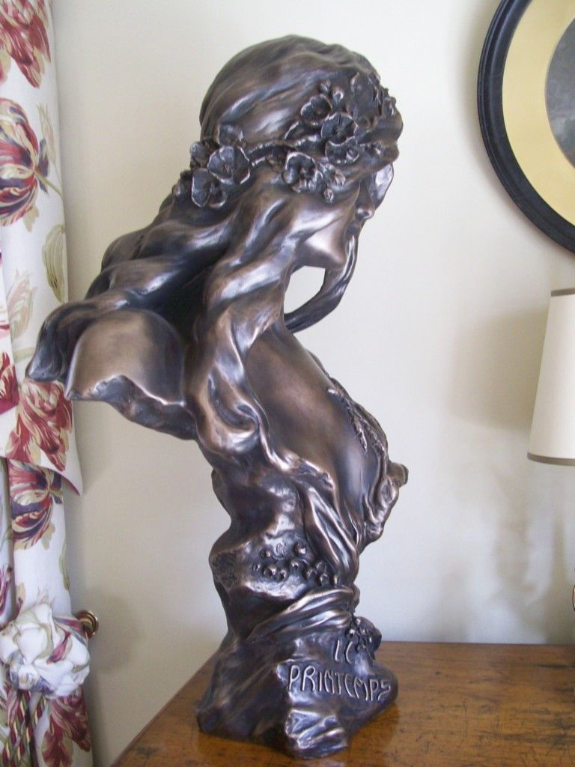

- Nude lady:
Art Nouveau Style Bronze Nude Lady. Classically styled bronze figurine of a young woman in artistic pose.

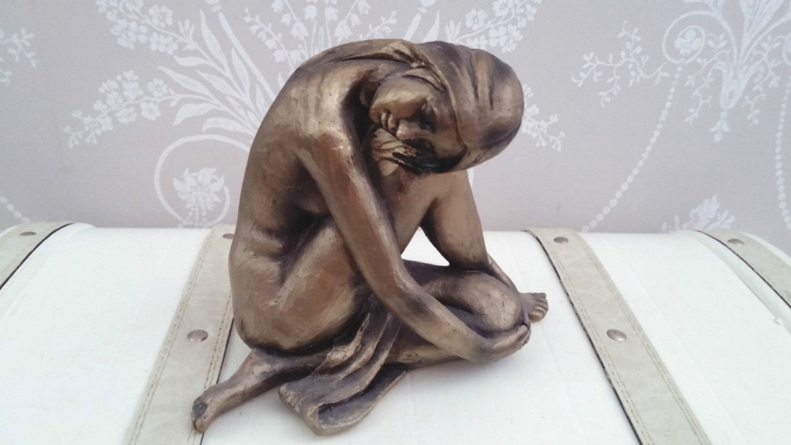
- Guardian angel figure:
Stunning sculpture of a guardian angel in the romantic Art Nouveau. Artistic sculpture “guardian angel " Alabaster Art Nouveau.
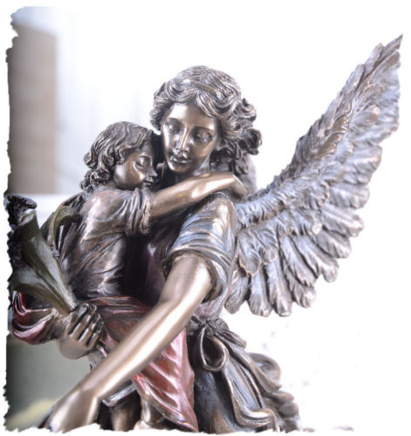

- A Moreau. Beautiful lady:
Length :33cm , height : 57cm,

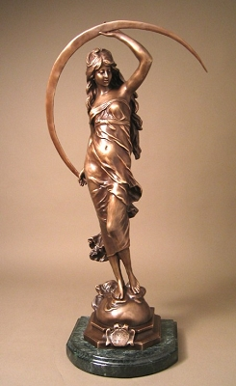
- Naked dancer bronze sculpture:

